Case Study

City of Temple Terrace
Building and Energy Solutions

The City of Temple Terrace, located just north of Tampa Bay, FL, is home to
25,000 residents. The City initiated a plan to invest in both its buildings and environment through an extensive Downtown Redevelopment Project.

ABM Building Services worked closely with City leaders to determine infrastructure needs, financial challenges and sustainability goals. Together they developed a financial program using the City’s Community Investment Tax funds to procure more than $3 million worth of critical infrastructure improvements.

By investing in energy-efficient upgrades, the City is creating savings to finance the upgrades without requiring additional taxpayer burden. Plus, the annual amount of the program’s energy savings, averaging more than $95,000 per year, will be monitored by ABM over
15 years to ensure the full amount is received. ABM estimates that operational savings, gained from reduced maintenance, emergency repair and replacement costs, will
amount to more than $100,000 per year
on top of the energy savings.
CHALLENGE

Temple Terrace had a mounting number of infrastructure improvements that needed to be made at several of its public buildings - with 57 percent of its HVAC equipment at 15 years old or older and several units showing signs
of deterioration. SOLUTION
• Installed 45 new HVAC units producing 240 tons of cooling capacity
• Added state-of-the-art HVAC controls

• Upgraded 1,600 lights to energy- efficient, long-lasting LED lighting
• Replaced leaking City Hall windows with impact-resistant, energy-efficient windows
BENEFIT
• Improved energy efficiency and reduced carbon emissions
• Enhanced indoor environmental quality including comfort conditions and lighting levels
• Guaranteed to produce $1.46M in energy and operational savings over a 15-year period
“This is a fantastic opportunity to upgrade our facilities, reduce energy costs and eliminate maintenance headaches; all with great financial benefits for the City and no burden on our taxpayers,”
said Michael Dunn, Public Information Officer for the City of Temple Terrace.

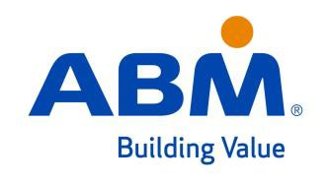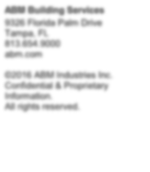

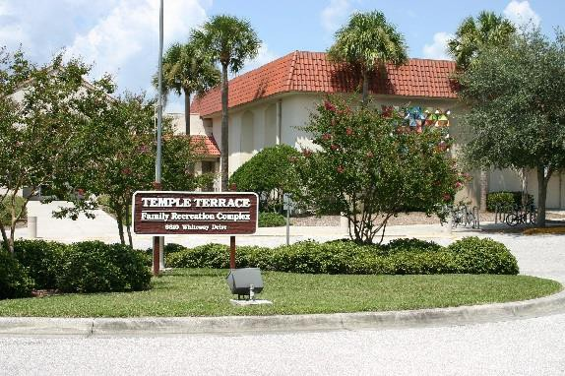ABM Building Services
9326 Florida Palm Drive
Tampa, FL
813.654.9000 abm.com

©2016 ABM Industries Inc. Confidential & Proprietary Information.
All rights reserved.

