--- MEDIA RELEASE ---
For Immediate Release
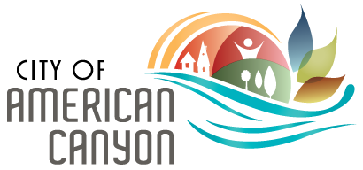

Landmark Sustainability Project in American Canyon
Projected to Capture Millions in Energy Savings

Solar, Energy Storage, and EV Charging to be Implemented with Zero Taxpayer Capital Expense
AMERICAN CANYON, Calif., May 22, 2020 – The American Canyon City Council has approved a landmark energy reduction and resiliency initiative that will implement long-term community goals for environmental stewardship. The comprehensive, turnkey project - which includes photovoltaic (PV) energy storage micro-grids, electric vehicle charging stations, equipment upgrades, and lighting retrofits - is expected to significantly reduce the City’s future energy footprint. Equally important, the improvement will save the City more than nine million dollars in future electrical costs with zero upfront capital investment.
The project will ensure the City remains a sustainability leader by reducing municipal green-house-gas emissions while concurrently providing critically needed resiliency as a hedge against future power outages. Construction, led by energy partner ENGIE North America and funded in part by the State of California, is scheduled to start in summer 2020 with completion expected in the first quarter of 2021.
“This crucial project demonstrates the City Council’s commitment to the community’s sustainability goals and its scope has recently evolved to include emergency utility power supply,” said American Canyon City Manager, Jason Holley. “Thanks to the comprehensive scope of the project, we are able to capture significant energy savings while positioning our municipal utility systems to withstand future losses of power. The City Council’s decisive action during these uncertain times, in conjunction with funding from the State, allows the City to take advantage of favorable financing conditions in pursuit of long-term sustainable outcomes. In addition, the City’s partnership with ENGIE will prioritize the utilization of local workforce and includes educational engagement opportunities for students to ensure our residents are an integral part of the success of our energy program development.”
The 5.2-million-dollar project is funded by a 15-year, 1.79 percent interest loan as well as a $300,000 grant received from the Governor’s Office of Emergency Services. The City will not incur any upfront costs or out-of-pocket expenses. Instead, the program is structured so that future energy cost savings are reinvested back into the City by paying off the loan.

