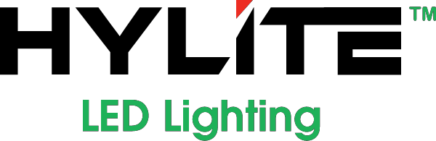 FOR IMMEDIATE RELEASE
September 5th, 2018

Contact:
HyLite LED, LLC
3705 Centre Circle
Fort Mill, SC 29715

Tel: 803.336.2230
Email: info@hylite.us

HyLite LED PAR46, PAR56 & PAR64 Ret rofit Soluti ons
Retrofit any Existing PAR46, PAR56 and PAR64 Applications!

Fort Mill, SC - HyLite LED is excited to announce new PAR46, PAR56 and PAR64 Retrofit Solutions! The HyLite LED Lotus Lamp is designed for a quick and easy installation in existing can lights. The HyLite LED Lotus Lamps feature excellent optics for Increased Visibility & Low Power Consumption, helping you to increase illumination while your reducing energy costs. It is available in multiple beam angles: 15⁰, 25⁰, 40⁰ and 120⁰ for Ideal Light Distribution. With lamp life of up to 60,000 hours, HyLite LED Lotus Lamps significantly reduce energy consumption & re-lamping, maintenance, and disposal costs. It enhances vision for better Optical Acuity. It also reduces light pollution while providing clean, crisp light where you need it. Available in both
3000K and 5000K, the HyLite LED Lotus Lamp allows you to easily retrofit any existing PAR46, PAR56, and
PAR64 application.

About HyLite LED, LLC
HyLite LED Lighting is a well-diversified manufacturer of high-quality, future-generation energy-efficient
lighting products that are engineered for years of dependable performance. Our company focuses on innovation by providing efficient and cost-effective lighting solutions. For more information visit our website: HyLiteLEDLighting.com.

