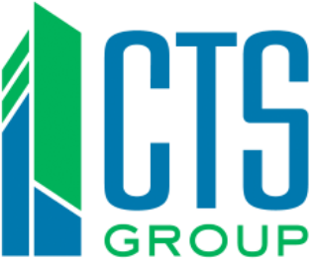

FOR IMMEDIATE RELEASE
JANUARY 30, 2017

Monroe County, Illinois Invests in Guaranteed Energy Savings Project
Green Technology Will Produce Eco-Friendly Environments, Improved Comfort and Cost Savings.

MONROE COUNTY, IL. — CTS Group, a St. Louis-based energy services company, along with the government of Monroe County, Illinois, announced that they are joining on a comprehensive $1.7 million energy savings performance contract (ESPC). The project scope will include the original courthouse, jail, highway department, Superintendent of Schools Building, and the Annex Building. Impending plans include energy-efficiency upgrades to the Oak Hill facility.

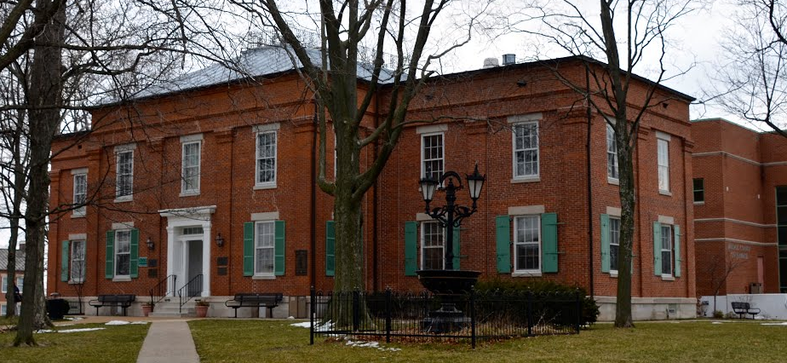
The Monroe County Courthouse, located in Waterloo, IL, was constructed in 1852-53 with additions of the wings in 1903 and another addition in 1995. The county’s main concern and initial reason for looking into this project was a focus on energy efficiency, along with escalating maintenance and repairs costs of the aging equipment.

The fiscally responsible ESPC, which is currently underway, will provide the county with widespread LED lighting and zoned heating and cooling, which will increase comfort while also reducing energy usage. The improvements at the courthouse building alone will reduce energy consumption in the facility by 28%. Savings from reduced energy and operational expenses will be used to help pay for the cost of the project. This project exemplifies the significant energy efficiency gains that can be achieved through strong, forward-thinking leadership in the community.

About Monroe County, IL
Monroe County recently celebrated its bicentennial, paying tribute to historical events leading up to its establishment on January 6, 1816. Its county seat and largest city is the community of Waterloo. The county is located in the southern portion of Illinois—known locally as "Little Egypt"—and is included in the St. Louis, MO-IL Metropolitan Statistical Area. According to the U.S. Census Bureau, as of 2015 Monroe County has an estimated population of 33,879 and a total area of 398 square miles.

About CTS Group
CTS Group is an energy services company that is the best in developing and implementing turnkey, comprehensive energy efficiency projects. They are a team of professionals dedicated to providing innovative energy efficient solutions that lead to a more comfortable and healthy environment. CTS Group is committed to meeting your needs and collaborating with you to accomplish them; that way they can ensure cost-effective, ethical, reliable, and high-quality solutions of strategic value. By promising excellent solutions – and delivering on them –CTS Group develops long-term partnerships built on a foundation of mutual trust and respect. For more information, visit www.ctsgroup.com or follow @CTSGroup_ESCO.

###

Media Contact:
Katie Stanfield
CTS Group
636.230.0843
kstanfield@ctsgroup.com
15933 Clayton Rd. St. Louis, MO 63011 www.ctsgroup.com 636.686.9848

